**PUEBLO UNION DEPOT**

In-House Catering Menu

Hors d’’ oeuvres

**$27.99 per Person**

**Choose Four**

Queso Dip with Tortilla Chips

Marinated Fresh Vegetables

Crostini with Assorted Toppings

Spinach Dip with French or Pumpernickel Bread

Crab Dip with Stone-Milled Crackers

Italian Stuffed Mushrooms

Fresh Fruit with Decadent Dip

Warm Jalapeno Crab Dip with Tortilla Chips

BLT Dip with Toasted Bread

Caramelized Onion Bacon Dip with Chips

Baked Flatbread with Assorted Toppings

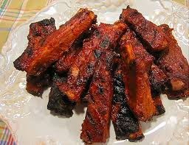 

**Special Order Items**

Sea Scallops Wrapped in Bacon ($2.99 Each, minimum Order of 200 Pieces)

Shrimp Wrapped in Bacon ($2.49 Each, Minimum Order of 200 Pieces)

**Choose Two**

Mini BBQ Ribs

Spring Rolls with Plum Sauce

Sliced Klobasi

Fire Roasted Hot Wings

Teriyaki Wings

Sliced Sausage with Pineapple and Red Pepper BBQ Sauce

Piquant Meatballs

Sliced Italian Sausage

Asian Dumplings with Ginger Dipping Sauce

** **

**Choose One**

Petite Cold Cuts and Cheeses with Cocktail Breads

Imported and Domestic Cheeses with Stone-Milled Crackers

Mini Pistachio Cheese Balls

Southwest Cheese Pinwheels

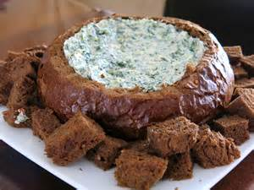 

**132 W. B. Street Pueblo, Colorado 81003 719-544-0020**

[**www.pueblouniondepot.com**](http://www.pueblouniondepot.com)

[uniondepot@comcast.net](mailto:uniondepot@comcast.net)

*Prices Subject to 20% Service Charge and 7.4% Sales Tax and Are Subject to Change Without Notice*

*2025*